Installing Plugins Manger

* 1. Follow the link [https://jmeter-plugins.org/install/Install/ and download](https://jmeter-plugins.org/install/Install/%20%20и%20) the plugins-manager.jar file

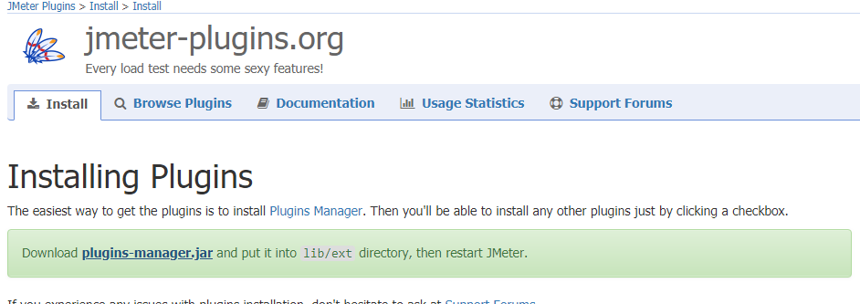

Picture 1

1.2 Save the file in this path *…\\apache-jmeter-3.0\\lib\\ext*

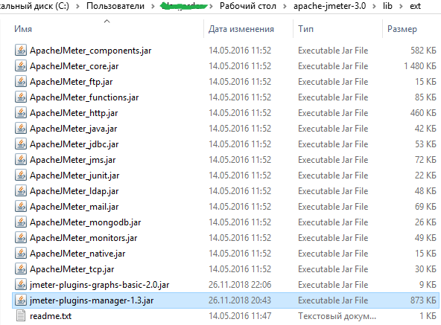

Picture 1.2

Options*->* Plugins Manger *->* Available plugins*->* 3 Basic Graph *(download)*

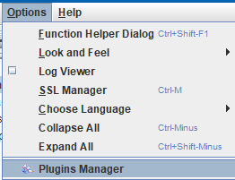

Picture 1.3

2.Create test

2.1 Create Test Plan ->Add->Threads ->Thread Group;

* Enter the number of users - 2
* Delay period -1
* Start duration 300 (seconds)

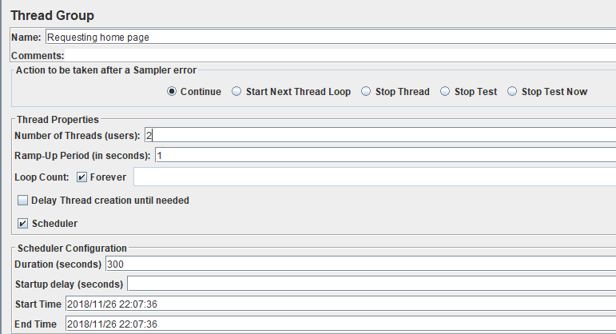

Picture 2.1

Accessing the home page Get home page (changed Thread Group)

Enter the website address automationpractice.com

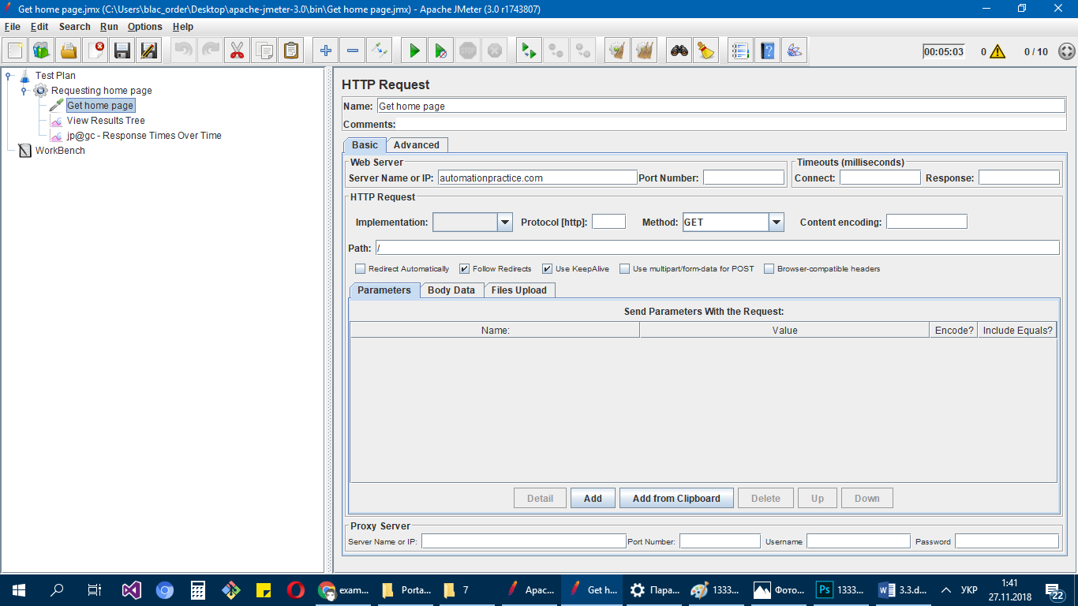

Picture 2.2

To see the result add Thread Group->Add->Listener-> jp@gc – Response Times Over Time

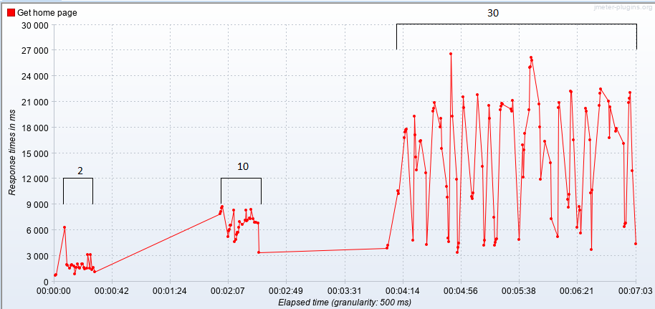

Picture 2.3

Setting the timer

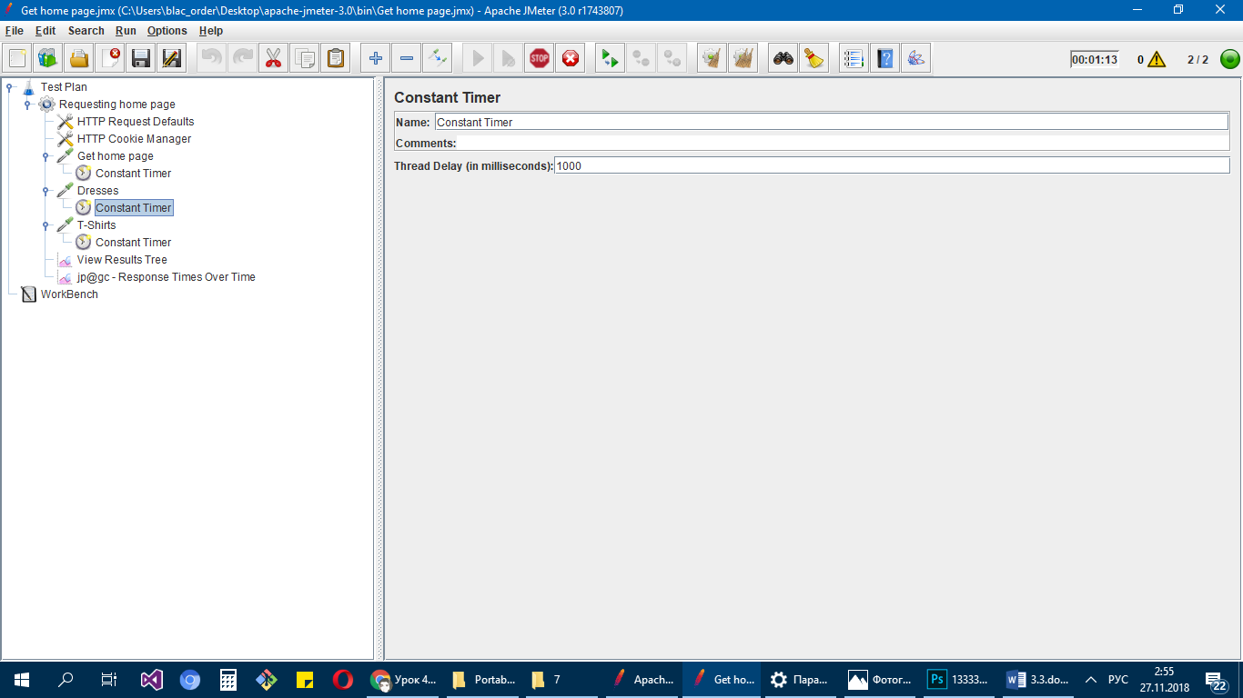

Picture 2.4

Result

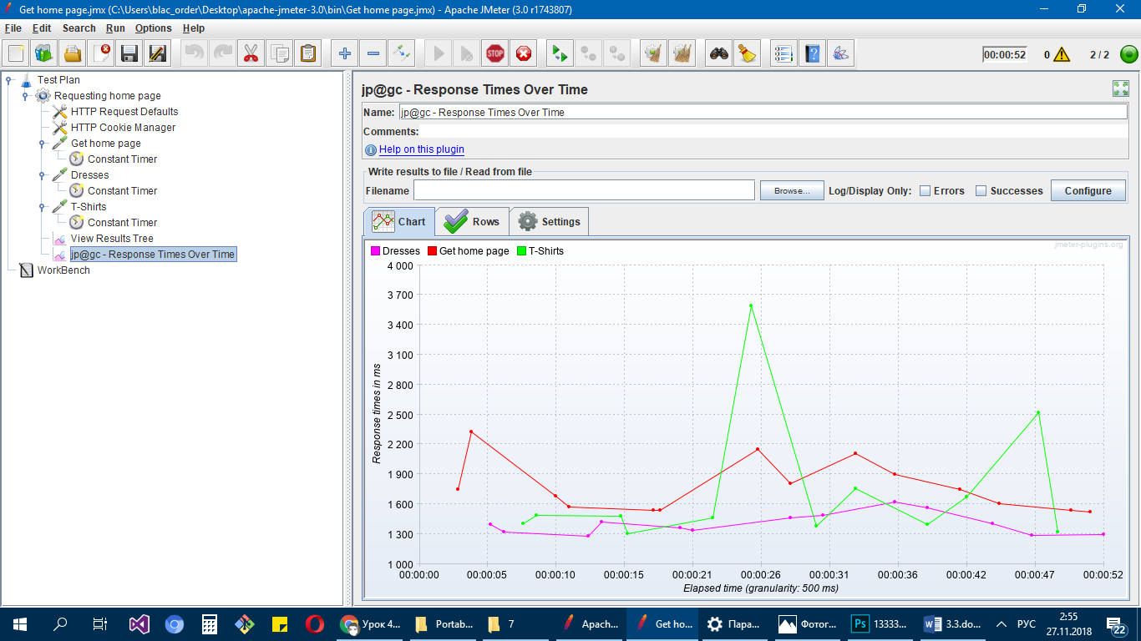

Picture 2.5